Lab Assignment – 3.1
AI Assisted Coding
E Srivarsha– 2303A52343
Batch-44
Question 1: Zero-Shot Prompting (Palindrome Number Program)
Prompt: Write a Python function that checks whether a given number is a palindrome
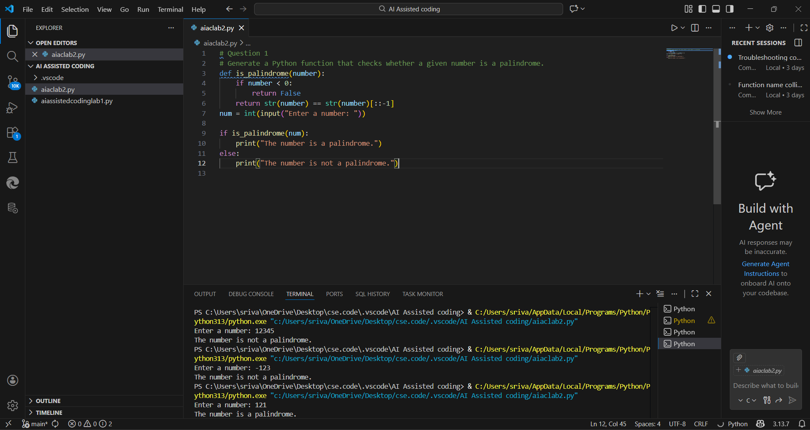
*Identify any logical errors or missing edge-case handling.
- Positive palindrome numbers (e.g., 121, 12321)
- Non-palindrome numbers (e.g., 123)
- Zero (0)
- -121 becomes "-121" which is not equal to "121-".
- Logical clarification needed: negative numbers are generally not considered palindromes.
Question 2: One-Shot Prompting (Factorial Calculation)
Prompt: Write a Python function to compute the factorial of a given number. Example: Input: 5 → Output: 120
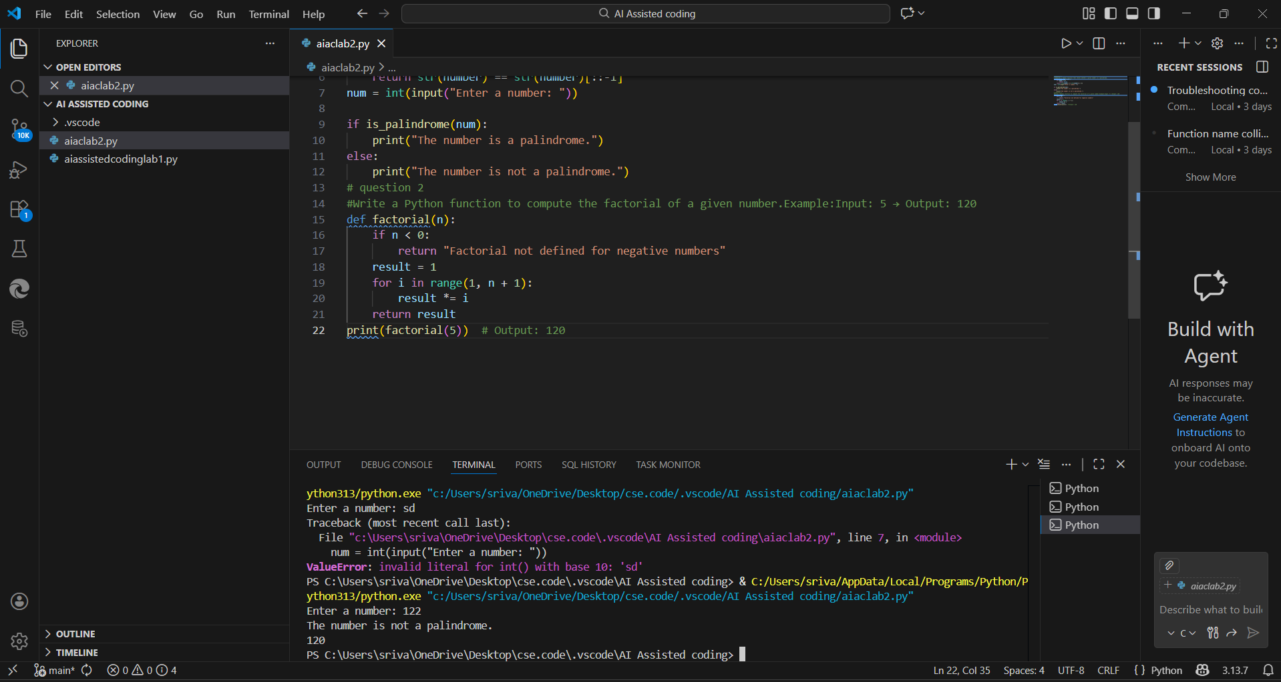 - One-shot prompting improves clarity and robustness compared to zero-shot prompting.
- Providing a single example helps the AI infer:
- Expected output format
- Correct logic
- Edge-case handling
One-shot prompts are especially useful for mathematical and logical problems.

Question 3: Few-Shot Prompting (Armstrong Number Check)
Prompt: Write a Python function to check whether a given number is an Armstrong number.Examples:
Input: 153 → Output: Armstrong Number Input: 370 → Output: Armstrong Number Input: 123 → Output: Not an Armstrong Number
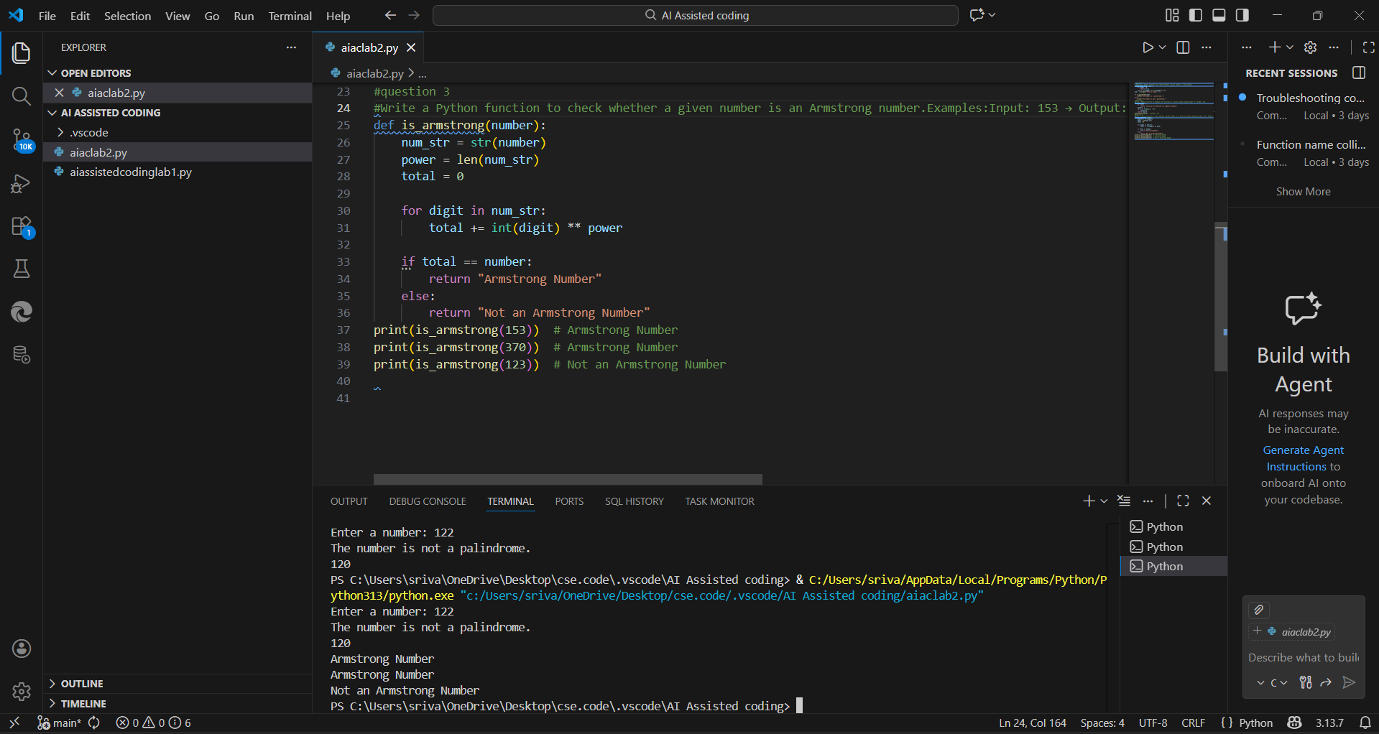
- Few-shot prompting significantly improves accuracy and output consistency.
- Multiple examples help the AI:
  - Infer exact output wording
  - Apply correct mathematical logic
  - Avoid ambiguity
- However, explicit edge-case examples are still required for:
  - Negative numbers
  - Non-integer inputs
Question 4: Context-Managed Prompting (Optimized Number
Classification)
Prompt: Act as an expert Python developer.
Generate an optimized Python program that classifies a given number as Prime, Composite, or Neither.
Constraints:
- Accept user input.
- Validate input (only non-negative integers allowed).
- If the number is ≤ 1, classify it as Neither.
- Use an optimized algorithm by checking divisibility only up to √n.
- Handle invalid inputs gracefully.
- Output must be exactly: "Prime", "Composite", or "Neither".
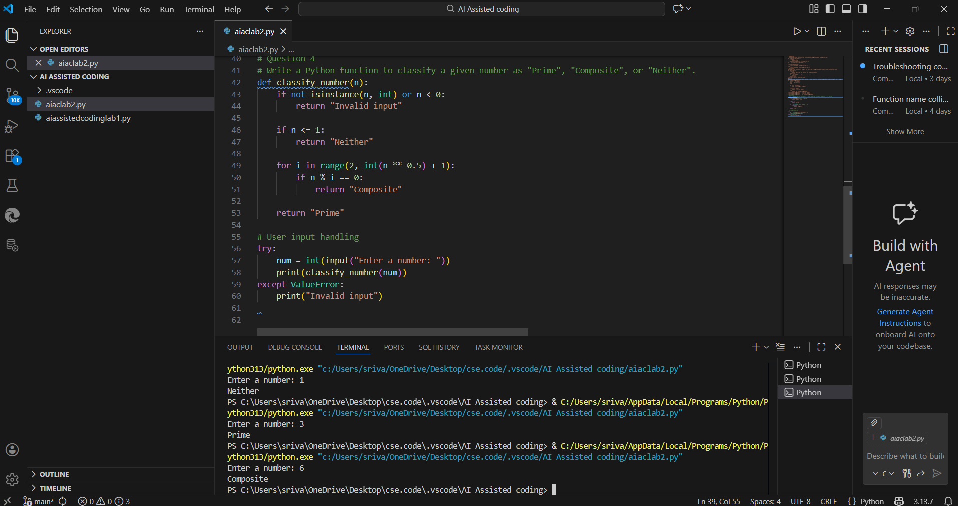
- Context-managed prompting delivers the best results due to:
  - Explicit constraints
  - Clear role definition
  - Performance optimization
- It significantly improves correctness, efficiency, and robustness
- This approach is ideal for real-world and production-level code generation
Question 5: Zero-Shot Prompting (Perfect Number Check)
Prompt: Write a Python function that checks whether a given number is a perfect number.
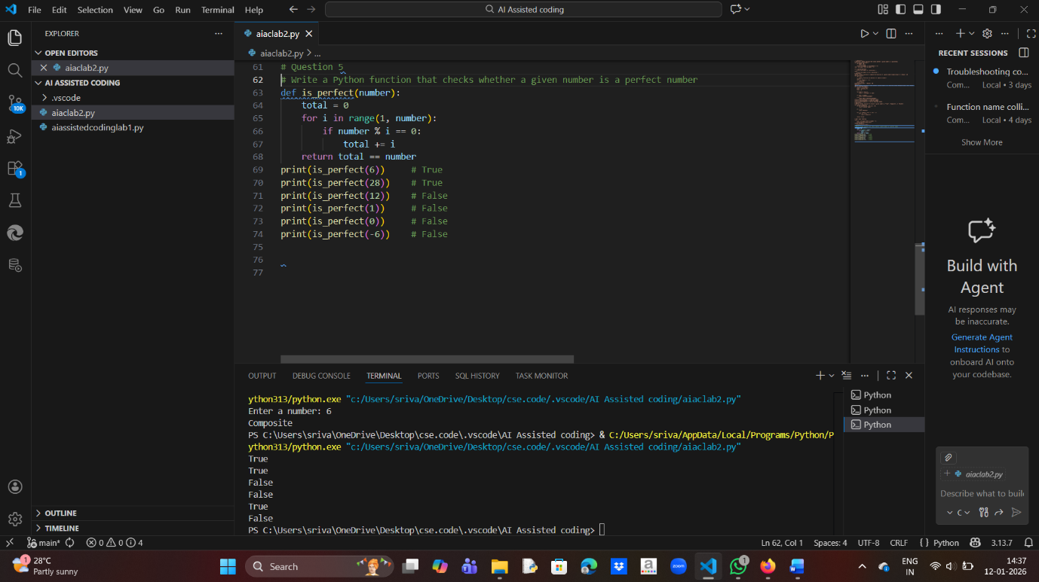
- Zero-shot prompting produced a correct but inefficient solution.
- Lacks:
  - Input validation
  - Explicit edge-case handling
  - Performance optimization
- This highlights how zero-shot prompts often generate basic, unoptimized logic.
Question 6: Few-Shot Prompting (Even or Odd Classification with
Validation)
Prompt: Write a Python program that determines whether a given number is Even or Odd.
Examples:
Input: 8 → Output: Even
Input: 15 → Output: Odd
Input: 0 → Output: Even. The program should validate input and handle invalid values gracefully.
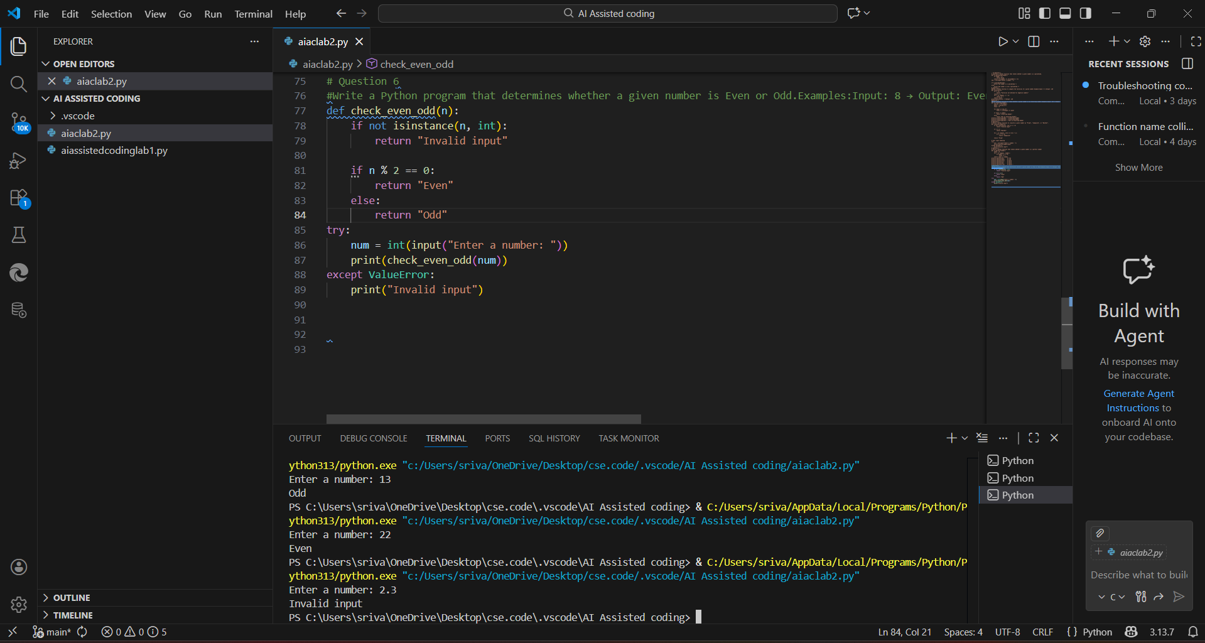
- Few-shot prompting improves output clarity and correctness.
- Multiple examples help the AI:
  - Infer expected output
  - Handle boundary values like zero
- It still requires explicit constraints for advanced validation.

